



**VEHICLE PRE-BOOKING APPLICATION**

## A PROJECT REPORT

***Submitted by***

## VIMALSHREE M (2303811724322122)

***in partial fulfillment of requirements for the award of the course***

## CGB1221 – DATABASE MANAGEMENT SYSTEMS

***in***

## ARTIFICIAL INTELLIGENCE AND DATA SCIENCE

**K. RAMAKRISHNAN COLLEGE OF TECHNOLOGY**

(An Autonomous Institution, affiliated to Anna University Chennai and Approved by AICTE, New Delhi)

**SAMAYAPURAM – 621 112**

**JUNE-2025**

# K. RAMAKRISHNAN COLLEGE OF TECHNOLOGY

# (AUTONOMOUS)

**SAMAYAPURAM – 621 112**

# BONAFIDE CERTIFICATE

Certified that this project report on **“VEHICLE PRE-BOOKING APPLICATION”** is the bonafide work of **VIMALSHREE M (2303811724322122)** who carried out the project work during the academic year 2024 - 2025 under my supervision.

|  |  |
| --- | --- |
| **SIGNATURE** | **SIGNATURE** |
| Dr. T. AVUDAIAPPAN M.E.,Ph.D., | Mrs.S.GEETHA,M.E., |
| **HEAD OF THE DEPARTMENT,**  PROFESSOR, | **SUPERVISOR,**  ASSISSTANT PROFESSOR, |
| Department of Artificial Intelligence, | Department of Artificial Intelligence, |
| K. Ramakrishnan College of Technology,  (Autonomous) | K. Ramakrishnan College of Technology, (Autonomous) |
| Samayapuram-621 112. | Samayapuram-621 112. |

Submitted for the viva-voce examination held on **04.06.25**

**INTERNAL EXAMINER EXTERNAL EXAMINER**

# DECLARATION

I declare that the project report on “**VEHICLE PRE-BOOKING APPLICATION**” is the result of original work done by me and best of my knowledge, similar work has not been submitted to “**ANNA UNIVERSITY CHENNAI**” for the requirement of Degree of **BACHELOR OF TECHNOLOGY**. This project report is submitted on the partial fulfillment of the requirement of the award of the **CGB1221–DATABASE MANAGEMENT SYSTEMS.**

**Signature**

**VIMALSHREE M**

**Place:** Samayapuram

**Date:** 04/06/2025

# ACKNOWLEDGEMENT

It is with great pride that I express my gratitude and indebtedness to my institution**, “K. Ramakrishnan College of Technology (Autonomous)”,** for providing me with the opportunity to do this project.

I glad to credit honourable chairman, **Dr. K. RAMAKRISHNAN, B.E.,** for having provided the facilities during the course of my study in college.

I would like to express my sincere thanks to my beloved Executive Director, **Dr. S. KUPPUSAMY, MBA, Ph.D.,** for forwarding my project and offering an adequate duration to complete my project.

I would like to thank **Dr. N. VASUDEVAN, M.Tech., Ph.D.,** Principal, who gave the opportunity to frame the project to full satisfaction.

I whole heartily thanks to **Dr.T.AVUDAIAPPAN, M.E.,Ph.D.,** Head of the Department, **ARTIFICIAL INTELLIGENCE,** for providing his encourage in pursuing this project.

I express my deep expression and sincere gratitude to my project supervisor **Mrs.S. GEETHA, M.E**., Department of **ARTIFICIAL INTELLIGENCE**, for her incalculable suggestions, creativity, assistance and patience which motivated me to carry out this project.

I render my sincere thanks to the Course Coordinator and other staff members for providing valuable information during the course.

I wish to express my special thanks to the officials and Lab Technicians of my departments who rendered their help during the period of the work progress.

## INSTITUTE:

## Vision:

* To serve the society by offering top-notch technical education on par with global standards.

## Mission:

* Be a center of excellence for technical education in emerging technologies by

exceeding the needs of industry and society.

* Be an institute with world class research facilities.
* Be an institute nurturing talent and enhancing competency of students to transform them as all- round personalities respecting moral and ethical values.

## DEPARTMENT

## Vision:

* To excel in education, innovation and research in Artificial Intelligence and Data Science to fulfill industrial demands and societal expectations.

**Mission:**

* To educate future engineers with solid fundamentals, continually improving teaching methods using modern tools.
* To collaborate with industry and offer top-notch facilities in a conductive learning environment.
* To foster skilled engineers and ethical innovation in AI and Data Science for global recognition and impactful research.
* To tackle the societal challenge of producing capable professionals by instilling employability skills and human values.

## PROGRAM EDUCATIONAL OBJECTIVES (PEOs)

* **PEO 1:** Compete on a global scale for a professional career in Artificial Intelligence and Data Science.
* **PEO 2:** Provide industry-specific solutions for the society with effective communication and ethics.
* **PEO 3:** Enhance their professional skills through research and lifelong learning initiatives.

**PROGRAM SPECIFIC OUTCOMES (PSOs)**

* **PSO1:** Capable of finding the important factors in large datasets, simplify the data, and improve predictive model accuracy.
* **PSO2:** Capable of analyzing and providing a solution to a given real-world problem by designing an effective program.

## PROGRAM OUTCOMES(POs)

Engineering students will be able to:

1. **Engineering knowledge:** Apply the knowledge of mathematics, science, engineering fundamentals, and an engineering specialization to the solution of complex engineering problems.
2. **Problem analysis:** Identify, formulate, review research literature, and analyze complex engineering problems reaching substantiated conclusions with consideration for sustainable development.
3. **Design/development of solutions:** Design solutions for complex engineering problems and design system components or processes that meet the specified needs with appropriate consideration for the public health and safety, and the cultural, societal, and environmental considerations.
4. **Conduct investigations of complex problems:** Use research-based knowledge and research methods including design of experiments, analysis and interpretation of data, and synthesis of the information to provide valid conclusions
5. **Modern tool usage:** Create, select, and apply appropriate techniques, resources, and modern engineering & IT tools including prediction and modeling to complex engineering activities with an understanding of the limitations.

vi

1. **The engineer and society:** Analyze and evaluate societal and environment aspects while solving complex engineering problems for its impact on sustainability with reference to economy, health, safety, legal, framework, culture and environment.
2. **Environment and sustainability:** Understand the impact of the professional engineering solutions in societal and environmental contexts, and demonstrate the knowledge of, and need for sustainable development.
3. **Ethics:** Apply ethical principles and commit to professional ethics, and responsibilities and norms of the engineering practice.
4. **Individual and collaborative team work:** Function effectively as an individual, and as a member or leader in diverse teams, and in multidisciplinary settings.
5. **Communication:** Communicate effectively on complex engineering activities with the engineering community and with society at large, such as, being able to comprehend and write effective reports and design documentation, make effective presentations, and give and receive clear instructions.
6. **Project management and finance:** Demonstrate knowledge and understanding of the engineering and management principles and apply these to one’s own work, as a member and leader in a team, to manage projects and in multidisciplinary environments.
7. **Life-long learning:** Recognize the need for, and have the preparation and ability to engage in independent and life-long learning in the broadest context of technological change.

# 

vii

# ABSTRACT

The **“**Vehicle Pre-Booking Application**”** is a web-based platform developed to streamline the process of vehicle reservation for users and administrative personnel. The primary goal is to overcome the inefficiencies of manual booking systems, such as lack of transparency, real-time data unavailability, and cumbersome management. This system provides functionalities like user registration and login, vehicle listing, booking, payment simulation, and feedback collection. Admins have dedicated controls to manage bookings, vehicles, and user information. Built using Flask for backend logic, HTML for frontend, and SQLite for database management, the application offers a secure, scalable, and responsive environment suitable for deployment in rental agencies, corporate fleets, or campus vehicle systems.

viii

# 

# ABSTRACT WITH POs AND PSOs MAPPING

# CO5: BUILD DATABASES FOR SOLVING REAL-TIME PROBLEMS.

| **ABSTRACT** | **POs MAPPED** | **PSOs MAPPED** |
| --- | --- | --- |
| The “Vehicle Pre-Booking Application” is a web-based platform developed to streamline the process of vehicle reservation for users and administrative personnel. The primary goal is to overcome the inefficiencies of manual booking systems, such as lack of transparency, real-time data unavailability, and cumbersome management. This system provides functionalities like user registration and login, vehicle listing, booking, payment simulation, and feedback collection. Admins have dedicated controls to manage bookings, vehicles, and user information. Built using Flask for backend logic, HTML for frontend, and SQLite for database management, the application offers a secure, scalable, and responsive environment suitable for deployment in rental agencies, corporate fleets, or campus vehicle systems. | **PO1 -3**  **PO2 -2**  **PO3 -3**  **PO4 -1**  **PO5 -3**  **PO6 -1**  **PO7 -1**  **PO8 -2**  **PO9 -2**  **PO10 -2**  **PO11 -2**  **PO12 -3** | **PSO1 -3**  **PSO2 -3** |

Note: 1- Low, 2-Medium, 3- High

# TABLE OF CONTENTS

|  |  |  |
| --- | --- | --- |
| **CHAPTER**  **No.** | **TITLE** | **PAGE**  **No.** |
|  | **ABSTRACT** | **viii** |
| **1** | **INTRODUCTION** | **01** |
|  | 1.1 OBJECTIVE | 01 |
|  | 1.2 OVERVIEW | 01 |
|  | 1.3 SQL AND DATABASE CONCEPTS | 02 |
| **2** | **PROJECT METHODOLOGY** | **03** |
|  | 2.1 PROPOSED WORK | 03 |
|  | 2.2 BLOCK DIAGRAM | 03 |
| **3** | **MODULE DESCRIPTION** | **04** |
|  | 3.1 AUTHENTICATION MODULE | 04 |
|  | 3.2 BOOKING MANAGEMENT MODULE | 04 |
|  | 3.3 USER BOOKING HISTORY MODULE | 04 |
|  | 3.4 ADMIN DASHBOARD MODULE | 04 |
|  | 3.5 USER FEEDBACK MODULE | 05 |
| **4** | **CONCLUSION & FUTURE SCOPE** | **06** |
|  | **APPENDIX A SOURCE CODE** | **07** |
|  | **APPENDIX B SCREENSHOTS** | **12** |
|  | **REFERENCES** | **14** |

**CHAPTER 1**  **INTRODUCTION**

### 1.1 OBJECTIVE

The key objectives of this project include:

* Providing secure user and admin authentication using hashed passwords and session control.
* Allowing users to browse available vehicles with real-time availability data.
* Supporting vehicle pre-booking with user-defined preferences such as date and type.
* Facilitating administrative oversight to approve or reject booking requests.
* Incorporating payment processing (simulated) and feedback collection for continuous improvement.
* Offering a responsive and intuitive user interface for both users and administrators.

### 1.2 OVERVIEW

The key objectives of this project include:

* Providing secure user and admin authentication using hashed passwords and session control.
* Allowing users to browse available vehicles with real-time availability data.
* Supporting vehicle pre-booking with user-defined preferences such as date and type.
* Facilitating administrative oversight to approve or reject booking requests.
* Incorporating payment processing (simulated) and feedback collection for continuous improvement.
* Offering a responsive and intuitive user interface for both users and administrators.

## ****1.3 SQL AND DATABSE CONCEPTS****

Key database concepts and SQL techniques used in this project include:

* **Relational Schema Design**: Tables like Users, Vehicles, Bookings, Payments, and Feedback are normalized and linked via primary and foreign keys.
* **Data Types**: Use of appropriate data types (e.g., TEXT, INTEGER, DATE) ensures accuracy and performance.
* **SQL Operations**: Core CRUD (Create, Read, Update, Delete) operations are used throughout the system.
* **Join Queries**: Employed to fetch booking history by linking users and vehicles.
* **Transactions**: Ensures booking and payment operations are atomic and consistent.
* **Constraints**: Enforced data integrity through unique constraints (e.g., usernames, vehicle IDs).

# CHAPTER 2

# PROJECT METHODOLOGY

### 2.1 PROPOSED WORK

The methodology adopted follows a modular design approach. Each feature is separated into functional components, enabling easy debugging, testing, and future scaling. The development process included:

* **Requirement analysis:** Identifying both functional and non-functional system requirements.
* **System design:** Creating wireframes, ER diagrams, and flowcharts.
* **Implementation:** Coding the modules with Flask and HTML templates.
* **Testing:** Performing both unit and integration testing.
* **Deployment (local):** Hosting on a local development server using Flask.
* **Evaluation:** Validating the system based on performance, usability, and scalability.

**2.2 BLOCK DIAGRAM**

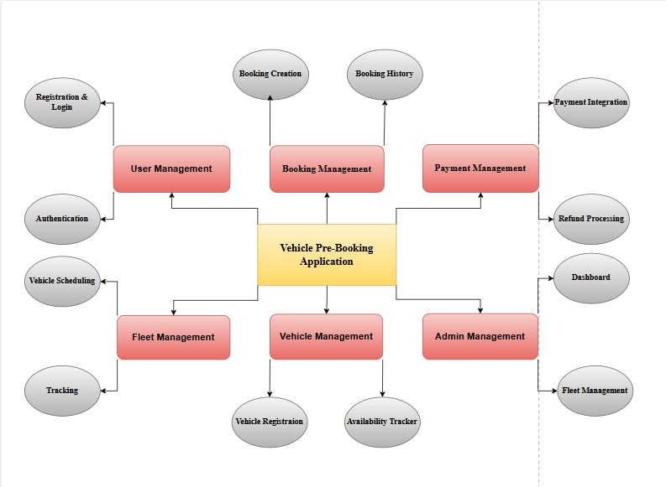

# CHAPTER 3

# MODULE DESCRIPTION

### 3.1 AUTHENTICATION MODULE

* Handles registration and login for both users and admins.
* Passwords are stored using hash functions for security.
* Session management ensures secure navigation.
* Account recovery via email link enhances accessibility.

### 3.2 BOOKING MANAGEMENT MODULE

* Users can filter vehicles by type (car, bike, etc.), availability, and booking date.
* Once booked, the status is marked as "Pending" until the admin takes action.
* Bookings can be approved/rejected by the admin.
* All booking details are stored and retrieved efficiently from the database.

### 3.3 USER BOOKING HISTORY MODULE

* Logged-in users can view a complete list of their current and past bookings.
* Details include vehicle type, registration number, date, status.
* Helps users keep track of upcoming reservations and previous transactions.
* Allows easy validation and reference of past activity.

### 3.4 ADMIN DASHBOARD MODULE

* View all registered users.
* Manage vehicle listings (add/edit/delete vehicles).
* Approve or reject pending bookings.
* Monitor feedback from users.
* Reset user accounts or passwords if needed.

**3.5 USER FEEDBACK MODULE**

* Enables users to share reviews, rate the booking process, and report issues.
* Feedback status can be marked as Published/Hidden by the admin.
* Published feedback is displayed on the admin dashboard for transparency and service
* improvement.

**CHAPTER 4**

**CONCLUSION & FUTURE SCOPE**

The Vehicle Pre-Booking Application provides a reliable and efficient system for managing vehicle reservations. It simplifies the process with secure login, real-time availability, booking history, and admin controls. Built using Flask, SQLite, and HTML/CSS, the application is lightweight, modular, and user-friendly. By automating manual tasks and improving transparency, it enhances the experience for both users and admins, making it suitable for real-world use and future upgrades.

**FUTURE SCOPE**

### ****Payment Gateway Integration:****

Integrating real-time payment gateways like Razorpay or PayPal will enable users to make secure online payments during booking, making the system fully functional and ready for real-world deployment.

### ****Mobile Application Development:****

Creating Android/iOS apps will provide users with easy access to the booking system on the go, improving usability and expanding the application's reach.

### ****GPS Tracking Integration:****

Adding GPS tracking for booked vehicles will enhance user confidence and transparency by allowing real-time location monitoring, especially useful for fleet or rental businesses.

# APPENDIX A – SOURCE CODE

Database: `vehiclebookings`

CREATE TABLE `tms_admin` (

`a_id` int(20) NOT NULL,

`a_name` varchar(200) NOT NULL,

`a_email` varchar(200) NOT NULL,

`a_pwd` varchar(200) NOT NULL

) ENGINE=InnoDB DEFAULT CHARSET=latin1;

INSERT INTO `tms_admin` (`a_id`, `a_name`, `a_email`, `a_pwd`) VALUES

(1, 'System Admin', 'admin@mail.com', 'codeastro.com');

CREATE TABLE `tms_feedback` (

`f_id` int(20) NOT NULL,

`f_uname` varchar(200) NOT NULL,

`f_content` longtext NOT NULL,

`f_status` varchar(200) NOT NULL

) ENGINE=InnoDB DEFAULT CHARSET=latin1;

INSERT INTO `tms_feedback` (`f_id`, `f_uname`, `f_content`, `f_status`) VALUES

(1, 'Elliot Gape', 'This is a demo feedback text. This is a demo feedback text. This is a demo feedback text.', 'Published'),

(2, 'Mark L. Anderson', 'Sample Feedback Text for testing! Sample Feedback Text for testing! Sample Feedback Text for testing!', 'Published'),

(3, 'Liam Moore ', 'test number 3', '');

CREATE TABLE `tms_pwd_resets` (

`r_id` int(20) NOT NULL,

`r_email` varchar(200) NOT NULL

) ENGINE=InnoDB DEFAULT CHARSET=latin1;

INSERT INTO `tms_pwd_resets` (`r_id`, `r_email`) VALUES

CREATE TABLE `tms_syslogs` (

`l_id` int(20) NOT NULL,

`u_id` varchar(200) NOT NULL,

`u_email` varchar(200) NOT NULL,

`u_ip` varbinary(200) NOT NULL,

`u_city` varchar(200) NOT NULL,

`u_country` varchar(200) NOT NULL,

`u_logintime` timestamp(6) NOT NULL DEFAULT CURRENT_TIMESTAMP(6) ON UPDATE CURRENT_TIMESTAMP(6)

) ENGINE=InnoDB DEFAULT CHARSET=latin1;

CREATE TABLE `tms_user` (

`u_id` int(20) NOT NULL,

`u_fname` varchar(200) NOT NULL,

`u_lname` varchar(200) NOT NULL,

`u_phone` varchar(200) NOT NULL,

`u_addr` varchar(200) NOT NULL,

`u_category` varchar(200) NOT NULL,

`u_email` varchar(200) NOT NULL,

`u_pwd` varchar(20) NOT NULL,

`u_car_type` varchar(200) NOT NULL,

`u_car_regno` varchar(200) NOT NULL,

`u_car_bookdate` varchar(200) NOT NULL,

`u_car_book_status` varchar(200) NOT NULL

) ENGINE=InnoDB DEFAULT CHARSET=latin1;

INSERT INTO `tms_user` (`u_id`, `u_fname`, `u_lname`, `u_phone`, `u_addr`, `u_category`, `u_email`, `u_pwd`, `u_car_type`, `u_car_regno`, `u_car_bookdate`, `u_car_book_status`) VALUES

(3, 'Demo', 'User', '070678909', '90100 Machakos ', 'Driver', 'demouser@tms.com', 'demo123', 'SUV', 'CA1001', '2022-09-01', 'Approved'),

(4, 'John', 'Settles', '7145698540', '45 Clearview Drive', 'Driver', 'johns@mail.com', 'password', '', '', '', ''),

(5, 'Joseph', 'Yung', '7896587777', '72 Doe Meadow Drive', 'Driver', 'joseph@mail.com', 'password', '', '', '', ''),

(6, 'Vincent', 'Pelletier', '4580001456', '58 Farland Avenue', 'Driver', 'vincentp@mail.com', 'password', '', '', '', ''),

(7, 'Jesse', 'Robinson', '1458887855', '73 Fleming Way', 'Driver', 'jesser@mail.com', 'password', '', '', '', ''),

(8, 'Nelson', 'Ford', '7458965874', '58 West Side Avenue', 'User', 'nelford@mail.com', 'password', 'Sedan', 'CA1690', '2022-09-13', 'Approved'),

(9, 'Paul', 'Mills', '7412563258', '12 Red Maple Drive', 'User', 'paul@mail.com', 'password', 'Sedan', 'CA2077', '2022-09-14', 'Pending'),

(10, 'Liam', 'Moore', '7410001212', '114 Bleck Street', 'User', 'liamoore@mail.com', 'password', 'Sedan', 'CA1690', '2022-09-14', 'Approved'),

(11, 'Jeff', 'Lewis', '7854545454', '114 Test Adr', 'User', 'jeff@mail.com', 'password', 'Sedan', 'CA7700', '2022-09-14', 'Pending'),

(12, 'Kenya', 'Norman', '7896547855', '114 Test Addr', 'User', 'normank@mail.com', 'password', 'Bus', 'CA7766', '2022-09-15', 'Pending');

CREATE TABLE `tms_vehicle` (

`v_id` int(20) NOT NULL,

`v_name` varchar(200) NOT NULL,

`v_reg_no` varchar(200) NOT NULL,

`v_pass_no` varchar(200) NOT NULL,

`v_driver` varchar(200) NOT NULL,

`v_category` varchar(200) NOT NULL,

`v_dpic` varchar(200) NOT NULL,

`v_status` varchar(200) NOT NULL

) ENGINE=InnoDB DEFAULT CHARSET=latin1;

INSERT INTO `tms_vehicle` (`v_id`, `v_name`, `v_reg_no`, `v_pass_no`, `v_driver`, `v_category`, `v_dpic`, `v_status`) VALUES

(3, 'Euro Bond', 'CA7766', '50', 'Vincent Pelletier', 'Bus', 'buscch.jpg', 'Available'),

(4, 'Honda Accord', 'CA2077', '5', 'Joseph Yung', 'Sedan', '2019_honda_accord_angularfront.jpg', 'Available'),

(5, 'Volkswagen Passat', 'CA1690', '5', 'Jesse Robinson', 'Sedan', 'volkswagen-passat-500.jpg', 'Available'),

(6, 'Nissan Rogue', 'CA1001', '7', 'Demo User', 'SUV', 'Nissan_Rogue_SV_2021.jpg', 'Available'),

(7, 'Subaru Legacy', 'CA7700', '5', 'John Settles', 'Sedan', 'Subaru_Legacy_Premium_2022_2.jpg', 'Available');

ALTER TABLE `tms_admin`

ADD PRIMARY KEY (`a_id`);

ALTER TABLE `tms_feedback`

ADD PRIMARY KEY (`f_id`);

ALTER TABLE `tms_pwd_resets`

ADD PRIMARY KEY (`r_id`);

ALTER TABLE `tms_syslogs`

ADD PRIMARY KEY (`l_id`);

ALTER TABLE `tms_user`

ADD PRIMARY KEY (`u_id`);

ALTER TABLE `tms_vehicle`

ADD PRIMARY KEY (`v_id`);

ALTER TABLE `tms_admin`

MODIFY `a_id` int(20) NOT NULL AUTO_INCREMENT, AUTO_INCREMENT=2;

ALTER TABLE `tms_feedback`

MODIFY `f_id` int(20) NOT NULL AUTO_INCREMENT, AUTO_INCREMENT=4;

ALTER TABLE `tms_pwd_resets`

MODIFY `r_id` int(20) NOT NULL AUTO_INCREMENT, AUTO_INCREMENT=3;

ALTER TABLE `tms_syslogs`

MODIFY `l_id` int(20) NOT NULL AUTO_INCREMENT;

ALTER TABLE `tms_user`

MODIFY `u_id` int(20) NOT NULL AUTO_INCREMENT, AUTO_INCREMENT=13;

ALTER TABLE `tms_vehicle`

MODIFY `v_id` int(20) NOT NULL AUTO_INCREMENT, AUTO_INCREMENT=8;

# APPENDIX B – SCREENSHOTS

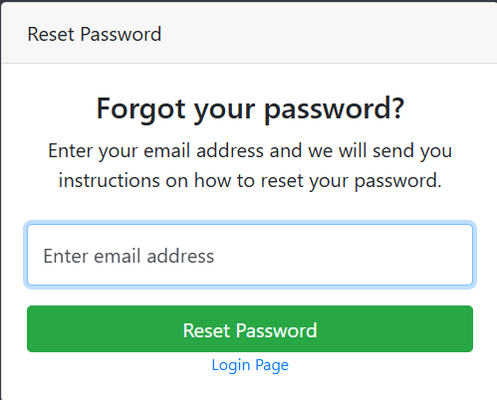

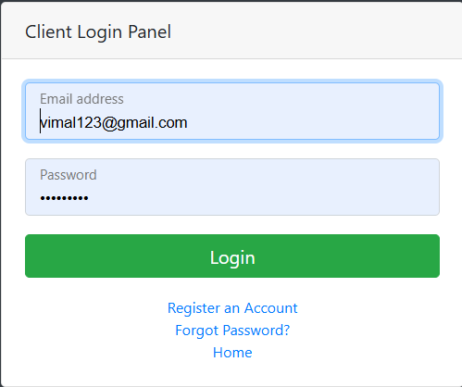

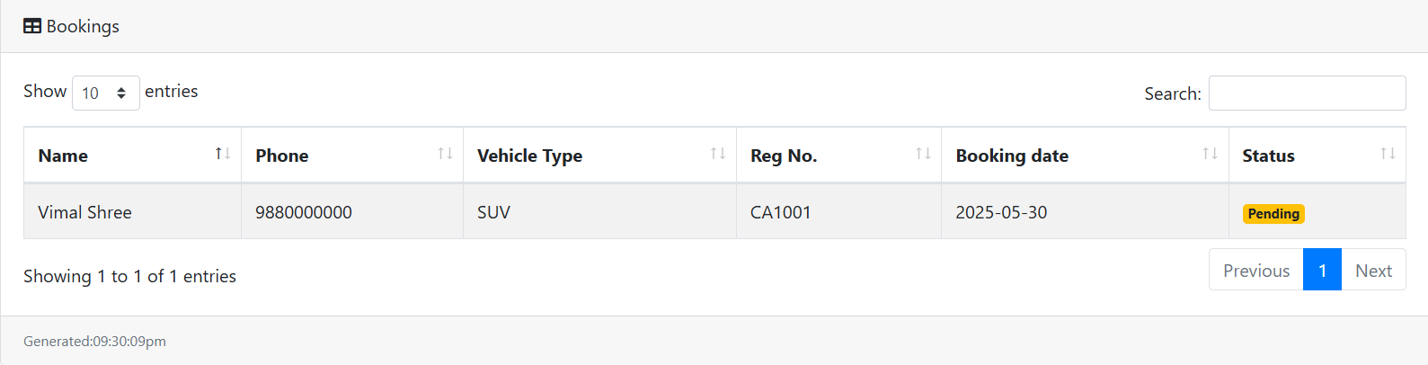

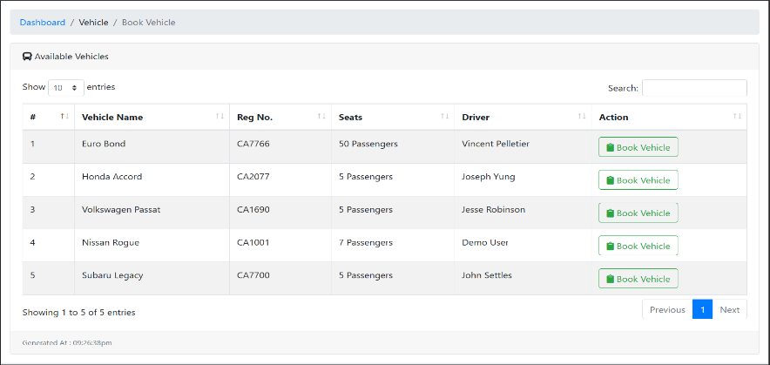

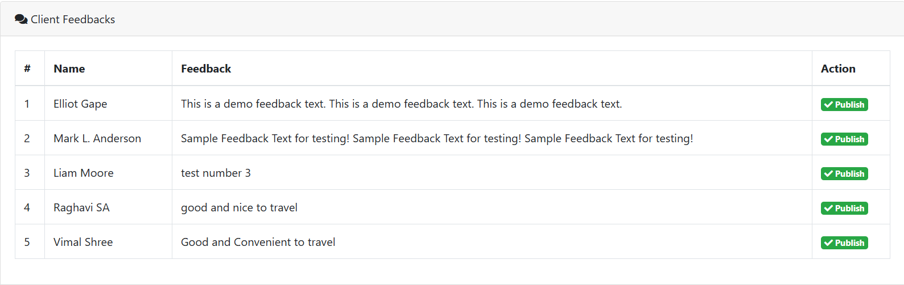

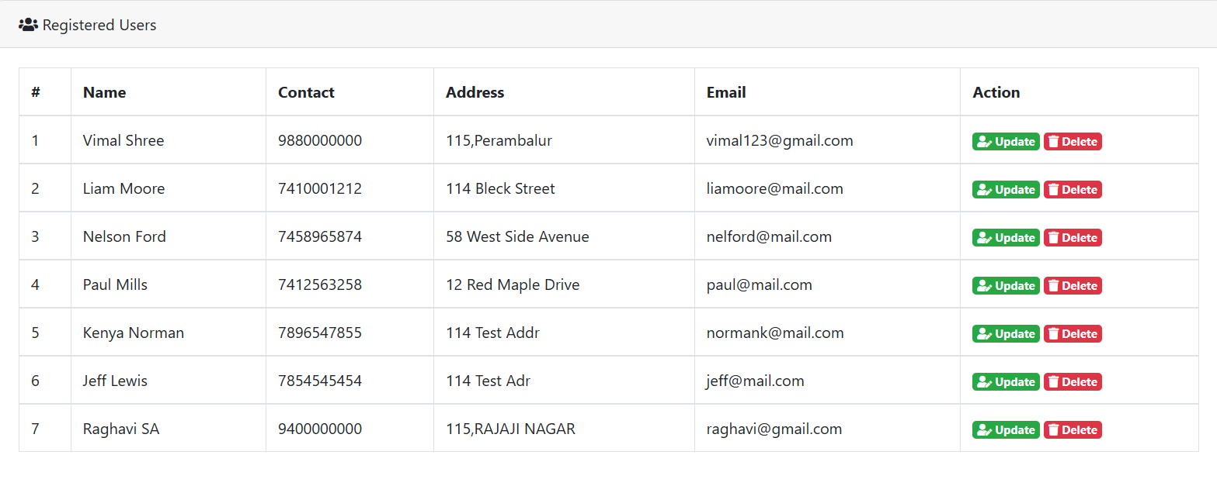

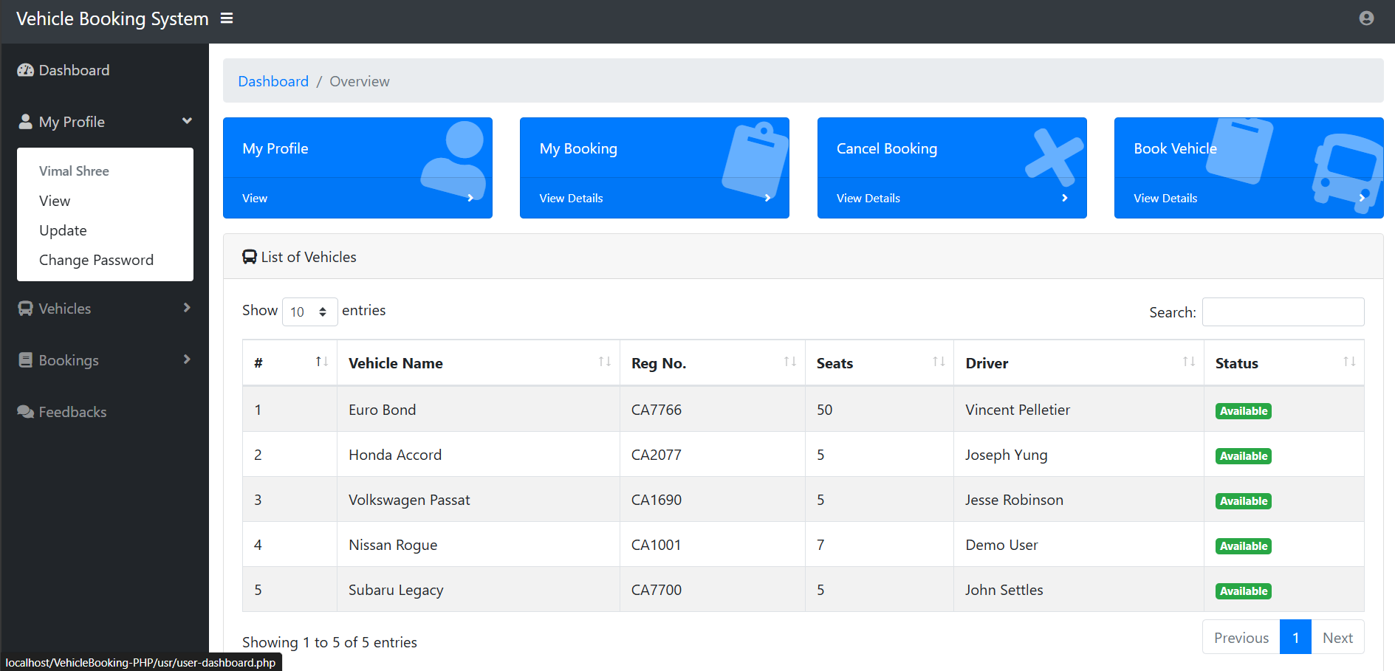

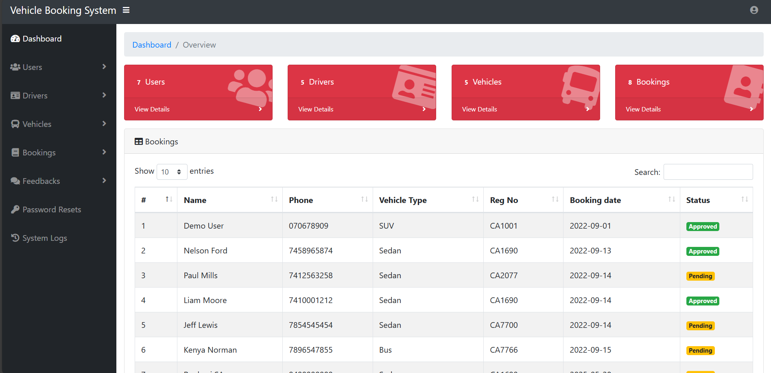

## ****REFERENCES****

1. Bootstrap Documentation – <https://getbootstrap.com/>
2. Flask Documentation – https://flask.palletsprojects.com/
3. Python Official Documentation – <https://docs.python.org/3/>
4. SQLite Documentation – https://www.sqlite.org/docs.html
5. W3Schools HTML/CSS Reference – <https://www.w3schools.com/>